ASSIGNMENT 4
OBJECT-ORIENTED SYSTEM DESIGN,
LAYERING, DESIGN PATTERNS & OODBMS

Name: MUKESH.M
Register Number: (192521368)
Department: _B.TECH (IT)
Course: Object-Oriented Analysis and Design
Assignment: Part I – Design (50 Marks) and Part II – Implementation (50 Marks)

PART I – DESIGN AND ARCHITECTURE

TASK 1 – From analysis model to system architecture

1.1 Identify and explain the layers
Layer | Responsibility | Typical classes/components | Must not do
View / Presentation | Displays screens, accepts user input, shows validation messages and results. | LoginView, StudentDashboard, CourseSearchView, RegistrationView, ResultView | Must not contain registration rules, SQL/OODBMS calls or persistent-object lifecycle code.
Application / Service | Coordinates a complete use case, controls transaction boundaries and calls domain/repository abstractions. | RegistrationController, RegistrationService, FeeService, ResultService | Must not render screens or depend on a specific database vendor.
Domain / Business | Represents core concepts, rules, state and business behaviour. | Student, Faculty, Course, Registration, Payment, Examination, Result, User | Must not format UI messages or perform vendor-specific persistence.
Data Access | Provides controlled create/read/update/delete and query operations for domain objects. | StudentRepository, CourseRepository, RegistrationRepository, PaymentRepository | Must not decide business policy or display UI.
OODBMS / Persistence | Stores persistent objects, identities, attributes and object references; manages transactions and recovery. | OODBMS engine, object store, persistence driver | Must not own presentation or application workflow decisions.

1.2 Assign classes/components to layers
Class / component | Layer | Reason
StudentView | View | Captures student actions and displays registration status.
CourseSearchView | View | Displays available courses and search results.
RegistrationController | Application / Controller | Maps a user action to a service call.
RegistrationService | Application / Service | Coordinates eligibility, capacity checking and registration.
FeeService | Application / Service | Coordinates fee calculation and payment workflow.
Student | Domain | Represents a student and student-related state.
Course | Domain | Represents course details and capacity rules.
Registration | Domain | Represents the association between a student and a course.
Payment | Domain | Represents payment amount, reference and status.
Result | Domain | Represents an examination result.
StudentRepository | Data Access | Persists and retrieves Student objects.
CourseRepository | Data Access | Finds courses and updates course records.
RegistrationRepository | Data Access | Stores registrations and finds related objects.
OODBMSAdapter | Persistence integration | Translates repository operations to the selected OODBMS API.

1.3 Layer interaction and request/response flow
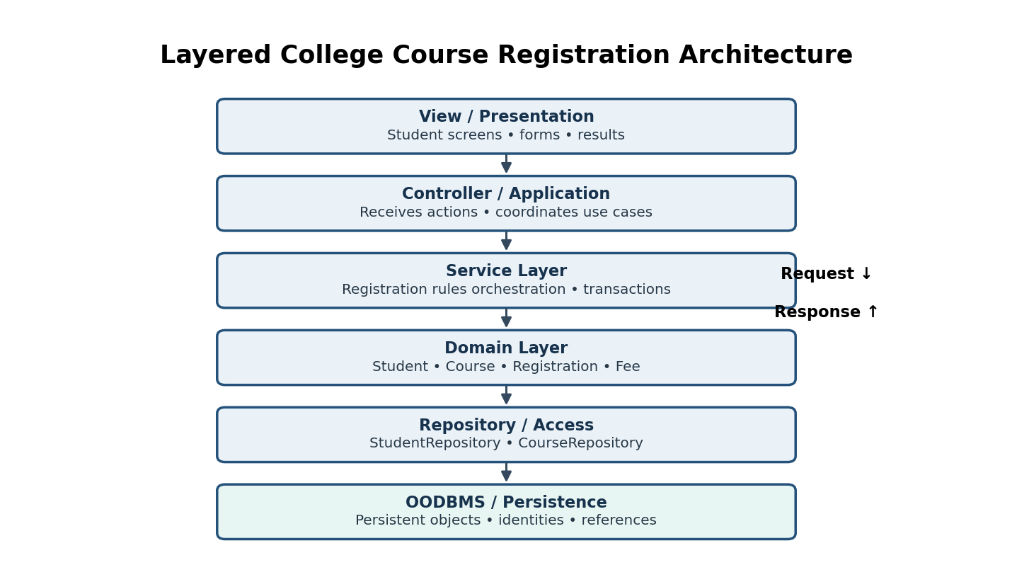
Figure 1. Layered architecture for the selected college registration system.
Request flow: the student submits a form in the View. The Controller validates request shape (for example, required identifiers) and calls RegistrationService. The service applies use-case policy and invokes domain behaviour. Repositories load or save domain objects through the OODBMS adapter. The result travels back through Service and Controller to the View.
Allowed dependencies: View → Controller/Application; Controller → Service; Service → Domain and repository interfaces; repository implementations → OODBMS driver. Domain objects should not call View classes or concrete OODBMS APIs. A repository interface may be defined near the domain/application boundary, while its implementation remains in the data-access layer.

1.4 Design defence (under 100 words)
Mixing presentation, business and persistence logic in one class creates high coupling and low cohesion. A screen change may accidentally affect registration rules, while a database change may require rewriting user-interface code. Testing also becomes difficult because the class needs a screen and database even when only one rule is being checked. Separate layers isolate change, make responsibilities clear, allow services and domain rules to be tested independently, and permit a repository implementation to be replaced without redesigning the user interface.

TASK 2 – Design principles in action

2.1 Diagnose the OrderManager design
Problem | Why it is a problem | Likely future impact
Too many responsibilities | OrderManager creates orders, charges payments, generates invoices, accesses storage, sends email and validates orders. | A small feature change can require editing a large class; regression risk increases.
High coupling | It depends on concrete payment, database and email implementations. | Replacing a provider or database forces changes in business workflow code.
Low cohesion | Unrelated tasks are grouped in one class. | The class is difficult to understand, reuse and maintain.
Poor testability | Tests may require a real database, payment gateway and email service. | Unit tests become slow, fragile and expensive; failures are harder to isolate.
Violation of dependency inversion | High-level order policy depends directly on low-level implementation details. | Infrastructure choices control the business design.

2.2 Apply SOLID principles
Principle | Proposed application | Benefit
SRP | OrderService coordinates order creation; PaymentService processes payment; InvoiceService creates invoices; NotificationService sends messages; OrderRepository persists orders; OrderValidator validates input. | Each component has one reason to change.
OCP | Define PaymentMethod interface and add CardPayment, UpiPayment or WalletPayment implementations without editing OrderService. | New payment types are added by extension.
LSP | Every PaymentMethod implementation honours the same contract: accepts a valid amount and returns a defined payment result or documented failure. | Any implementation can replace another without breaking the caller's expectations.
ISP | Use focused interfaces such as PaymentProcessor, InvoiceGenerator and NotificationSender rather than one large service interface. | Clients depend only on operations they use.
DIP | OrderService receives OrderRepository and PaymentProcessor abstractions through constructor injection. | Business policy is independent of concrete infrastructure.

2.3 Dependency redesign
// Abstraction used by the business service
class OrderRepository {
public:
virtual void save(const Order& order) = 0;
virtual Order* findById(int orderId) = 0;
virtual ~OrderRepository() = default;
};
// High-level policy depends on the abstraction, not DatabaseManager
class OrderService {
OrderRepository& repository;
public:
explicit OrderService(OrderRepository& repo) : repository(repo) {}
void placeOrder(const Order& order) {
// validate and apply business rules here
repository.save(order);
}
};
// A concrete OODBMS repository implements OrderRepository.
The dependency direction is OrderService → OrderRepository abstraction ← OODBMSOrderRepository. The concrete repository depends on the abstraction; the service does not know which database vendor is used.

2.4 Design defence
SOLID improves maintainability by limiting the effect of change. SRP makes each class easier to understand, OCP supports new behaviour without repeatedly editing stable code, and DIP isolates business rules from infrastructure. Focused interfaces reduce unnecessary dependencies, while LSP ensures interchangeable implementations behave consistently. For testing, interfaces allow fake repositories and payment processors to be injected, so business logic can be tested without connecting to a live database or payment provider.

TASK 3 – Select the right design pattern

3.1 Pattern selection
Hospital requirement | Suitable pattern | Reason
Create different notification types | Factory Method | A creator selects and constructs Email, SMS or app notification objects while the client uses a common interface.
Only one application configuration object | Singleton | A single shared configuration instance is exposed through a controlled access point.
Support different payment mechanisms | Strategy | Card, UPI and insurance payment algorithms can be selected at runtime behind one interface.
Notify multiple components when patient status changes | Observer | Registered observers receive an update when the subject changes state.
Separate object creation from the client | Factory Method (or Abstract Factory for families) | The client requests an abstraction rather than constructing concrete classes directly.

3.2 Strategy pattern design
Intent: define a family of payment algorithms, encapsulate each one, and make them interchangeable without changing the checkout workflow.
Participants: PaymentStrategy (interface); CardPayment, UpiPayment and InsurancePayment (concrete strategies); PaymentService (context); Hospital billing workflow (client).
Responsibilities and relationships: PaymentService holds a PaymentStrategy reference and delegates payment execution to it. Each concrete strategy implements the same operation. The client chooses or receives the appropriate strategy based on payment choice or policy.
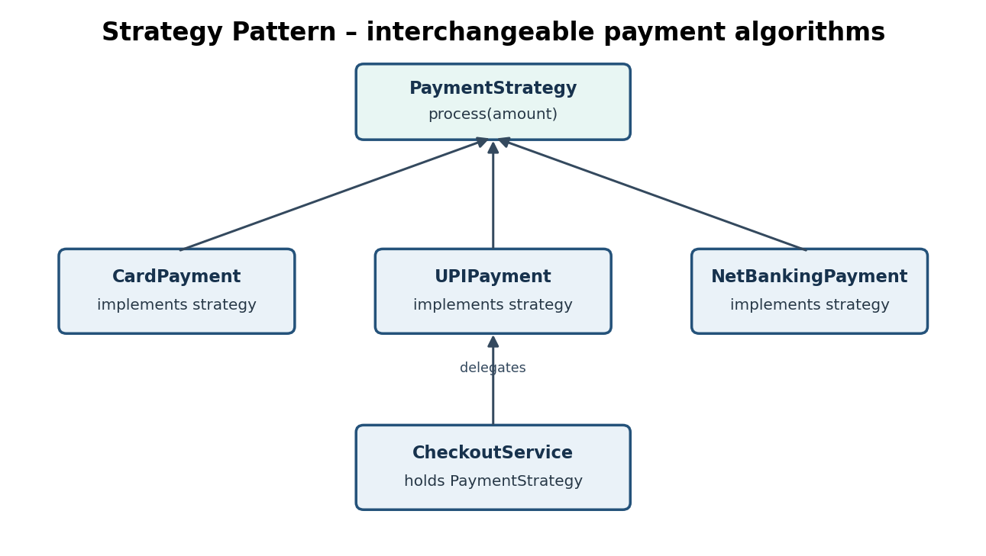
Figure 2. Strategy pattern for interchangeable payment methods.
Interaction: (1) patient selects a payment method; (2) the application selects the matching strategy; (3) PaymentService invokes process(amount); (4) the strategy communicates with its payment provider; (5) a result is returned to the service and shown to the user.

3.3 Strategy versus Factory
Aspect | Strategy | Factory
Purpose | Changes the algorithm/behaviour used to perform an operation. | Encapsulates the decision and process of creating an object.
Use when | Several interchangeable ways exist to perform a task, such as payment or discount calculation. | The client should not know concrete constructor details or creation rules.
Coupling effect | Client depends on a strategy interface rather than each algorithm class. | Client depends on a product interface rather than concrete product constructors.
Misuse risk | Too many tiny strategies can add unnecessary classes and selection complexity. | A factory for a single trivial object may add needless indirection.

3.4 Pattern defence
A pattern should be used only when the design has the problem the pattern is intended to solve. Adding patterns without need introduces extra classes, interfaces and indirection. This can make a small system harder to read and maintain. The correct choice depends on the change expected, the responsibilities involved and the coupling that needs to be reduced.

TASK 4 – Access layer and OODBMS design

4.1 Persistent object analysis
Class | Object identity | Important attributes | Relationships | Persist? / reason
Member | memberId | name, email, phone, membershipStatus | Has many Loan objects | Yes; member and borrowing history must survive sessions.
Book | bookId / accessionNo | title, ISBN, publicationYear, availabilityStatus | Has Author reference(s); appears in Loan | Yes; catalogue and availability are core records.
Author | authorId | name, biography | Associated with one or more Book objects | Yes; author details are shared and reused.
Loan | loanId | issueDate, dueDate, returnDate, status | References one Member and one Book | Yes; transaction and history must be retained.
Fine | fineId | amount, assessedDate, paidStatus | Associated with a Loan and Member | Yes; financial liability and payment status must persist.
Librarian | librarianId | name, staffCode, role | Processes Loan and Fine operations | Yes; accountability and staff records are required.

4.2 Repository/data-access design
Repository | Representative operations
MemberRepository | create(Member), findById(id), update(Member), delete(id), findLoans(memberId)
BookRepository | create(Book), findById(id), update(Book), delete(id), findByAuthor(authorId), findAvailable()
LoanRepository | create(Loan), findById(id), update(Loan), delete(id), findActiveByMember(memberId), findByBook(bookId)
FineRepository | create(Fine), findById(id), update(Fine), delete(id), findUnpaidByMember(memberId)
AuthorRepository | create(Author), findById(id), update(Author), findBooks(authorId)

4.3 Persist Member → Loan → Book
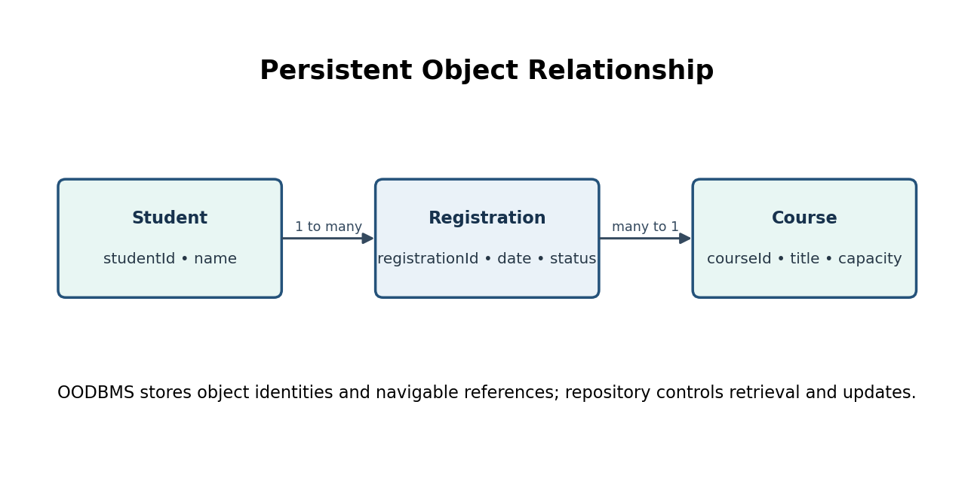
Figure 3. Object relationships in the library example.
Each object receives a stable identity (for example, memberId, loanId and bookId). A Loan stores references to the Member and Book objects rather than duplicating all their attributes. When a member's loan history is requested, MemberRepository or LoanRepository follows the stored relationship and retrieves the related objects.
Update: changing a Loan's returnDate or status is performed through LoanRepository and committed as a transaction. Deletion: a Loan should generally be retained as historical evidence or marked cancelled/closed rather than physically removed. If deletion is permitted, referential rules must prevent dangling references. Deleting a Book that is referenced by an active Loan should be rejected or handled through an explicit archival policy.

4.4 Access-layer architecture
The repository boundary isolates object queries from services. The OODBMS stores persistent object instances and references. The repository maps application operations to the selected OODBMS API, handles not-found cases and participates in transaction management. The domain model remains independent of the database vendor.

TASK 5 – View layer and MVC design

5.1 MVC components
MVC part | Online examination example | Responsibility
Model | Student, Examination, Question, Answer, Result and related services/domain state. | Represents data and business behaviour; validates domain rules.
View | Login screen, examination list, question page, answer form and result page. | Displays information and collects user input.
Controller | LoginController, ExamController, ResultController. | Receives user actions, validates request format and invokes application services.

5.2 MVC interaction – answer submission
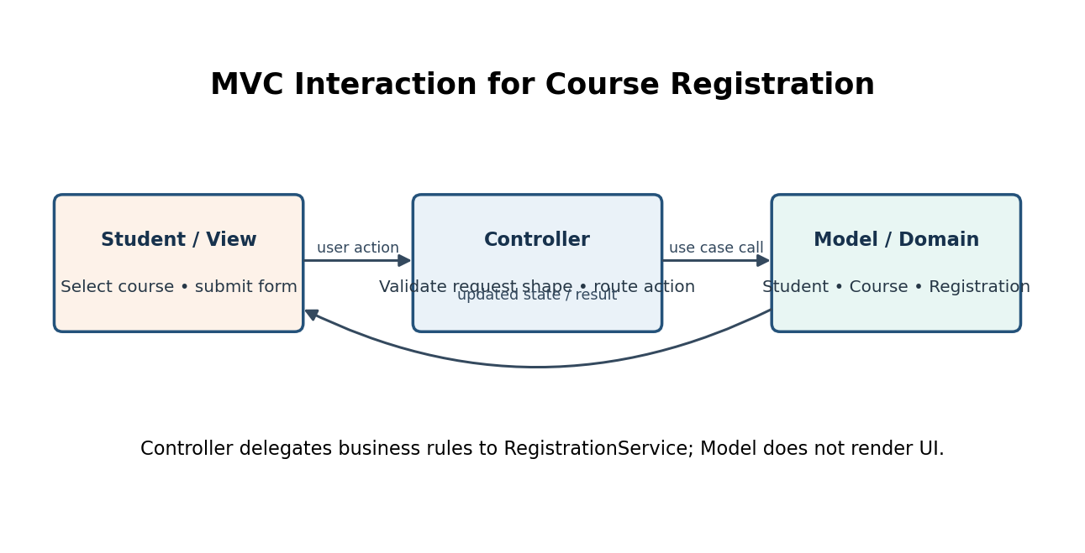
Figure 4. MVC responsibilities and interaction.
Detailed path: Student → ExaminationView → ExamController → ExamService → Examination/Answer domain objects → AnswerRepository → OODBMS. The repository stores the answer and returns a result. The service calculates or schedules result processing according to the business rules. The controller selects a response model, and the View displays confirmation or validation errors.

5.3 Prevent layer leakage
Inappropriate dependency | Why it is wrong | Correction
View directly queries OODBMS | UI becomes tied to storage schema and database API. | View calls Controller; Controller calls Service; Service uses repository interface.
Domain object displays UI messages | Domain becomes dependent on a presentation technology and cannot be reused easily. | Domain returns state or domain results; View formats user-facing messages.
Controller directly updates database objects | Controller takes on business and persistence responsibilities. | Controller delegates to Service; Service uses repositories.
Service contains SQL/vendor-specific calls | Business workflow becomes difficult to test or migrate. | Move persistence code to repository implementation.

5.4 Design defence
The View should not contain business rules because its purpose is to present information and collect input. If rules are placed in the View, another interface such as a mobile app may duplicate them and produce inconsistent outcomes. Business rules belong in the domain or service layer, where they can be reused by different views and tested independently.

TASK 6 – Integrated OOAD architecture: College Course Registration System

Stage 1 – Refine the analysis model
Domain class | Key attributes | Responsibilities / associations
Student | studentId, name, email, programme, status | Maintains student identity; associated with multiple Registrations.
Faculty | facultyId, name, department | Represents academic staff; may teach multiple Courses.
Course | courseId, title, credits, capacity, enrolledCount | Maintains course details and capacity; taught by Faculty.
Registration | registrationId, registeredAt, status | Connects one Student to one Course; validates its own state transitions.
Payment | paymentId, amount, status, transactionRef | Records fee payment for a registration or semester.
Examination | examId, courseId, date | Represents an examination for a Course.
Result | resultId, studentId, examId, marks, grade | Stores the outcome for a student's examination.
User | userId, username, passwordHash, role | Represents authenticated identity and access role.

Stage 2 – Define the architecture
Figure 5. Integrated layered architecture (selected system).
The View layer contains login, course search and registration screens. The Controller receives user actions. RegistrationService coordinates eligibility and capacity checks. Domain objects represent Student, Course and Registration. Repositories provide persistence abstractions, and an OODBMS adapter stores objects and their references.

Stage 3 – Apply design principles
Principle | Where applied | Problem prevented
SRP | RegistrationService coordinates registration; CourseRepository stores/retrieves courses; RegistrationRepository stores registrations. | Prevents one class from owning UI, business rules and database work.
DIP | RegistrationService depends on ICourseRepository and IRegistrationRepository interfaces. | Prevents business rules from depending on a specific OODBMS.
OCP | PaymentProcessor and NotificationSender interfaces allow new implementations. | Prevents repeated edits to stable workflow code when a provider is added.
Encapsulation | Course controls capacity and exposes a registration operation rather than allowing arbitrary enrolledCount changes. | Prevents invalid state updates from unrelated classes.

Stage 4 – Apply two design patterns
Pattern 1 – Repository: Problem: services should not contain database-specific queries. Solution: StudentRepository, CourseRepository and RegistrationRepository expose domain-oriented operations. Participants: repository interfaces, concrete OODBMS repositories, domain objects and services. Reason: persistence details are isolated and can be replaced or faked during tests.
Pattern 2 – Strategy: Problem: the system may support different fee-payment mechanisms. Solution: PaymentStrategy is implemented by CardPayment, UpiPayment and NetBankingPayment. Participants: PaymentStrategy, concrete strategies, PaymentService (context) and the student-facing client. Reason: payment behaviour can vary without changing registration workflow.
Figure 6. Strategy pattern used for fee payment.
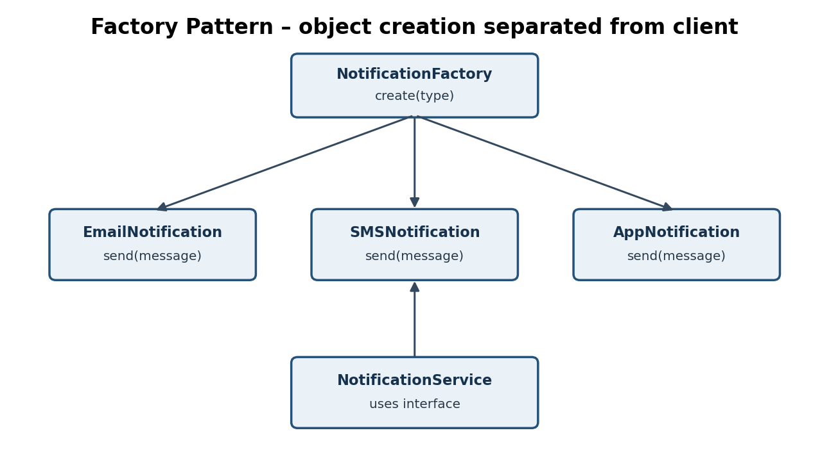
Figure 7. Factory pattern alternative for constructing notification objects.

Stage 5 – View/access integration
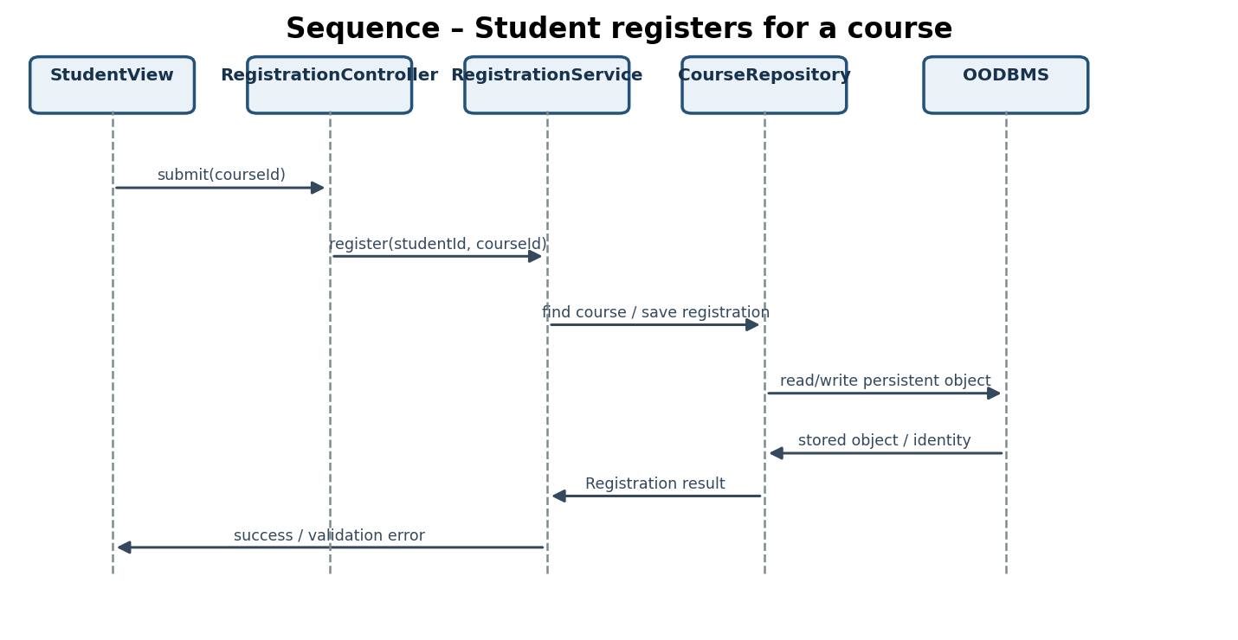
Figure 8. Sequence diagram for course registration.
The sequence begins when the student submits a course identifier. The controller forwards the request to RegistrationService. The service retrieves the Student and Course through repositories, checks that the student is active and the course has capacity, creates a Registration domain object, and asks RegistrationRepository to persist it. The response returns to the View as a success or a meaningful failure.

Stage 6 – Architecture evaluation
Quality | Evaluation
Low coupling | Views depend on controllers; services depend on repository interfaces; domain objects do not depend on the OODBMS.
High cohesion | Each service, repository and domain class has a focused responsibility.
Maintainability | Changes to UI or storage can be isolated from domain rules.
Reusability | RegistrationService can be called by web, desktop or mobile controllers.
Testability | Fake repositories and payment strategies can be injected into unit tests.
Extensibility | New payment methods and notification channels can be added behind interfaces.
Persistence independence | Repository interfaces hide the OODBMS-specific driver.
Separation of concerns | Presentation, use-case coordination, business state and persistence are distinct.

Requirement-to-component traceability
Requirement from brief | Proposed component(s) | Evidence
Student registration | RegistrationView, RegistrationController, RegistrationService, Student, Course, Registration | Sequence diagram; success/failure test.
Course registration | CourseRepository, RegistrationRepository, OODBMS adapter | Repository operations and persistence test.
Faculty management | Faculty domain class, FacultyService, FacultyRepository | Class allocation and CRUD test.
Fee payment | Payment domain class, PaymentService, PaymentStrategy | Strategy diagram and multiple strategy tests.
Examination management | Examination domain class, ExaminationService, ExaminationRepository | Domain model and repository test.
Result publication | Result domain class, ResultService, ResultRepository, ResultView | Result retrieval and display test.

PART II – IMPLEMENTATION, INTEGRATION, TESTING AND OODBMS VALIDATION
Implementation scope: the code is a compact C++17 demonstration of the selected College Course Registration System. It implements domain classes, service coordination, repository abstraction, an in-memory adapter, a Strategy pattern for payment, and test scenarios. It demonstrates the architecture and object flow. Replace the in-memory repository with a real OODBMS adapter for final database evidence.

TASK 1 – Implement the layered architecture

1.1–1.3 C++ implementation (domain, repository and service)
#include <iostream>
#include <string>
#include <unordered_map>
#include <memory>
#include <vector>
#include <stdexcept>
using namespace std;
// DOMAIN LAYER
class Student {
public:
int id;
string name;
bool active;
Student(int i, string n, bool a=true) : id(i), name(n), active(a) {}
};
class Course {
public:
int id;
string title;
int capacity;
int enrolled;
Course(int i, string t, int c) : id(i), title(t), capacity(c), enrolled(0) {}
bool hasSeat() const { return enrolled < capacity; }
void reserveSeat() {
if (!hasSeat()) throw runtime_error("Course is full");
++enrolled;
}
};
class Registration {
public:
int id, studentId, courseId;
string status;
Registration(int r, int s, int c)
: id(r), studentId(s), courseId(c), status("CONFIRMED") {}
};
// REPOSITORY ABSTRACTIONS
class IStudentRepository {
public:
virtual Student* findById(int id) = 0;
virtual ~IStudentRepository() = default;
};
class ICourseRepository {
public:
virtual Course* findById(int id) = 0;
virtual void update(const Course& course) = 0;
virtual ~ICourseRepository() = default;
};
class IRegistrationRepository {
public:
virtual void save(const Registration& registration) = 0;
virtual bool exists(int studentId, int courseId) = 0;
virtual ~IRegistrationRepository() = default;
};
// IN-MEMORY ADAPTER FOR DEMONSTRATION ONLY.
// Replace this adapter with an implementation using your selected OODBMS API.
class MemoryStore : public IStudentRepository,
public ICourseRepository,
public IRegistrationRepository {
unordered_map<int, Student> students;
unordered_map<int, Course> courses;
vector<Registration> registrations;
public:
void addStudent(const Student& s) { students.emplace(s.id, s); }
void addCourse(const Course& c) { courses.emplace(c.id, c); }
Student* findById(int id) override {
auto it = students.find(id);
return it == students.end() ? nullptr : &it->second;
}
Course* findById(int id) override {
auto it = courses.find(id);
return it == courses.end() ? nullptr : &it->second;
}
void update(const Course& c) override {
courses.insert_or_assign(c.id, c);
}
void save(const Registration& r) override {
registrations.push_back(r);
}
bool exists(int studentId, int courseId) override {
for (const auto& r : registrations)
if (r.studentId == studentId && r.courseId == courseId)
return true;
return false;
}
size_t registrationCount() const { return registrations.size(); }
};
// APPLICATION / SERVICE LAYER
class RegistrationService {
IStudentRepository& students;
ICourseRepository& courses;
IRegistrationRepository& registrations;
int nextRegistrationId = 1;
public:
RegistrationService(IStudentRepository& s, ICourseRepository& c,
IRegistrationRepository& r)
: students(s), courses(c), registrations(r) {}
string registerStudent(int studentId, int courseId) {
Student* student = students.findById(studentId);
if (!student) return "Rejected: student not found";
if (!student->active) return "Rejected: student is inactive";
Course* course = courses.findById(courseId);
if (!course) return "Rejected: course not found";
if (registrations.exists(studentId, courseId))
return "Rejected: duplicate registration";
if (!course->hasSeat()) return "Rejected: course is full";
course->reserveSeat();
courses.update(*course);
Registration registration(nextRegistrationId++, studentId, courseId);
registrations.save(registration);
return "Success: registration confirmed";
}
};
int main() {
MemoryStore store;
store.addStudent(Student(101, "Arun"));
store.addStudent(Student(102, "Meena", false));
store.addCourse(Course(501, "Object Oriented Design", 1));
RegistrationService service(store, store, store);
cout << service.registerStudent(101, 501) << endl;
cout << service.registerStudent(101, 501) << endl;
cout << service.registerStudent(102, 501) << endl;
cout << service.registerStudent(999, 501) << endl;
cout << "Stored registrations: " << store.registrationCount() << endl;
return 0;
}
Compile with a C++17 compiler: g++ -std=c++17 main.cpp -o registration_app. Run: ./registration_app (Windows: registration_app.exe). This is C++ code, not C. It uses classes and virtual interfaces to demonstrate OO layering.

Expected sample output
Success: registration confirmed
Rejected: duplicate registration
Rejected: student is inactive
Rejected: student not found
Stored registrations: 1

1.4 Boundary test
Attempt: call the OODBMS driver directly from StudentView or add a database connection field to Student. Expected architectural result: the design review/test should reject this dependency. Correction: StudentView calls RegistrationController; the controller calls RegistrationService; the service uses repository interfaces. A compile-time architecture test or code review can enforce module dependency rules.

TASK 2 – Design pattern implementation

2.1 Strategy pattern – payment implementation
#include <iostream>
#include <memory>
#include <string>
using namespace std;
class PaymentStrategy {
public:
virtual bool pay(double amount) = 0;
virtual ~PaymentStrategy() = default;
};
class CardPayment : public PaymentStrategy {
public:
bool pay(double amount) override {
cout << "Card payment processed: " << amount << endl;
return amount > 0;
}
};
class UpiPayment : public PaymentStrategy {
public:
bool pay(double amount) override {
cout << "UPI payment processed: " << amount << endl;
return amount > 0;
}
};
class PaymentService {
unique_ptr<PaymentStrategy> strategy;
public:
explicit PaymentService(unique_ptr<PaymentStrategy> s)
: strategy(move(s)) {}
bool checkout(double amount) {
if (amount <= 0) return false;
return strategy->pay(amount);
}
};
int main() {
PaymentService card(make_unique<CardPayment>());
PaymentService upi(make_unique<UpiPayment>());
card.checkout(1500.0);
upi.checkout(750.0);
}
Requirement change: add NetBankingPayment as another class implementing PaymentStrategy. PaymentService does not need to be rewritten; the client supplies the new strategy. The pattern reduces dependency on specific payment algorithms.

2.2 Factory pattern – notification creation
#include <iostream>
#include <memory>
#include <string>
using namespace std;
class Notification {
public:
virtual void send(const string& message) = 0;
virtual ~Notification() = default;
};
class EmailNotification : public Notification {
public:
void send(const string& m) override { cout << "EMAIL: " << m << endl; }
};
class SMSNotification : public Notification {
public:
void send(const string& m) override { cout << "SMS: " << m << endl; }
};
class NotificationFactory {
public:
static unique_ptr<Notification> create(const string& type) {
if (type == "email") return make_unique<EmailNotification>();
if (type == "sms") return make_unique<SMSNotification>();
throw invalid_argument("Unsupported notification type");
}
};
int main() {
auto n1 = NotificationFactory::create("email");
auto n2 = NotificationFactory::create("sms");
n1->send("Course registration confirmed");
n2->send("Your class begins tomorrow");
}
The factory moves construction decisions out of client code. A production design may use a registry or Factory Method hierarchy if notification types grow. A simple static factory is sufficient for this small demonstration.

TASK 3 – OODBMS integration and object persistence
The assignment requires a real OODBMS database, persistent classes, identity, relationships and create/read/update/delete evidence. The code above currently uses MemoryStore, which loses data when the process exits. It proves repository separation but does not meet the requirement for durable OODBMS persistence.
To complete actual integration, choose an OODBMS supported in the lab and implement the same interfaces using its C++ API. Store Student, Course and Registration objects with stable IDs. Registration must retain references or foreign object identifiers to its Student and Course. Use transactions so course seat reservation and registration creation either both commit or both roll back.
Operation | Required demonstration | Evidence to capture
Create | Create Student, Course and Registration objects and commit them. | Database browser/query showing object IDs and attributes.
Read | Close/reopen the application and retrieve by object ID. | Retrieved values after restart.
Update | Change Course capacity or Registration status and commit. | Before/after database view.
Delete | Delete or archive a test object according to relationship constraints. | Deletion result and proof no dangling reference exists.
Relationship retrieval | Load Registration and navigate to its Student and Course references. | Output showing related Student and Course IDs/names.
Failure handling | Request an invalid ID or simulate database unavailable. | Handled error message; no crash or partial update.

TASK 4 – View layer integration
A console view is sufficient for a basic prototype, but the assignment asks for a usable View supporting at least three operations. A suitable menu is: (1) student login, (2) search/list courses, (3) register for a course, (4) view registration status. The console should only collect input and display the returned service result; it should not access MemoryStore or an OODBMS driver.
Example console interaction
1. Login
2. List courses
3. Register for course
4. View registration
0. Exit
Enter choice: 3
Student ID: 101
Course ID: 501
Result: Success: registration confirmed
Input validation: reject non-numeric identifiers, missing values, IDs less than or equal to zero, and unknown identifiers. Boundary validation: test a course with exactly one remaining seat, then attempt another registration after capacity reaches zero.

TASK 5 – Test, debug and refactor

5.1 Functional test cases
Test ID | Input / condition | Expected result | Prototype behaviour
TC01 | Active student + existing course + available seat | Registration succeeds | Success message; registration count increases.
TC02 | Student ID does not exist | Reject; no data change | Student-not-found rejection.
TC03 | Inactive student | Reject; no data change | Inactive-student rejection.
TC04 | Same student registers for same course twice | Reject duplicate | Duplicate-registration rejection.
TC05 | Course capacity already reached | Reject course full | Course-full rejection when attempted.
TC06 | Course ID does not exist | Reject; no data change | Course-not-found rejection.
TC07 | Database/OODBMS unavailable | Return persistence error and roll back | Must be tested in real adapter; not simulated by MemoryStore.
TC08 | Retrieve registration after application restart | Object and references remain available | Not supported by MemoryStore; required in OODBMS adapter.

5.2 Pattern behaviour tests
- Strategy test A: CardPayment receives a positive amount and returns success.
- Strategy test B: UpiPayment receives a positive amount and returns success.
- Invalid amount test: PaymentService rejects zero or negative amount before invoking the strategy.
- Factory test: email and SMS types produce different concrete notification objects; an unsupported type raises a controlled exception.

5.3 Failure handling and 5.4 refactoring
Before: RegistrationService could directly create an OODBMS session and execute vendor-specific queries. Problem: service logic becomes difficult to unit-test and database migration changes business code. After: service depends on IStudentRepository, ICourseRepository and IRegistrationRepository. Improvement: repository adapters can be substituted, and tests can use in-memory fakes.
A further improvement for production is to make the seat update and registration save one transaction. If saving the Registration fails after the seat count changes, the transaction must roll back. The simple in-memory sample does not implement transaction rollback; this is an explicit limitation to address in the OODBMS adapter.

5.5 Engineering reflection
The refactoring increases cohesion because each repository owns persistence operations and RegistrationService owns the use case. It reduces coupling because the service knows interfaces rather than a database implementation. It improves maintainability because storage changes are localized. It improves testability because fake repositories can simulate successful reads, missing objects and persistence failures.

TASK 6 – Complete implementation challenge

6.1 End-to-end use case
Use case: an active student registers for an available course. The View collects student and course identifiers. The Controller validates the request format. RegistrationService checks the student, course, duplicate registration and capacity. The Course domain object reserves a seat. CourseRepository updates the course and RegistrationRepository stores a Registration. The OODBMS commits both changes. The service returns success, and the View displays confirmation.

6.2 Change the business rule
New rule: a student may register for at most five courses. Add a RegistrationRepository method countByStudent(studentId). RegistrationService checks whether the count is already five before creating a new Registration. This change belongs in the application/domain policy layer and repository query abstraction. The View, Course class and OODBMS adapter interface remain unchanged; the concrete repository adds the count query.

6.3 Change the persistence requirement
If management changes the persistence technology, implement a new concrete adapter for the repository interfaces. RegistrationService and domain classes remain unchanged. This is possible because the service depends on abstractions rather than a vendor API. The object identity and relationship mapping must still be preserved in the new adapter.

6.4 Break your own system – failure scenarios
Scenario | Expected behaviour | Correction / validation
Invalid student ID | Return student-not-found; do not create Registration. | Validate repository result; test unknown ID.
Duplicate registration | Reject the second registration. | Check existing relationship and enforce a unique constraint in persistence.
Course full | Reject without changing registration count. | Check capacity inside a transaction to avoid race conditions.
OODBMS connection failure | Return persistence-unavailable; no partial seat update. | Use transaction rollback and controlled exception mapping.
Invalid relationship | Reject Registration if Student or Course reference is missing. | Validate references before commit and enforce referential integrity.

6.5 Viva defence – suggested answers
Viva question | Answer
Why separate View and Domain? | The View handles interaction; the Domain owns business state and rules. This avoids UI technology leaking into business logic.
Why use patterns? | Repository isolates persistence; Strategy makes payment algorithms interchangeable; Factory separates notification construction.
Which class has the highest responsibility? | RegistrationService coordinates the registration use case, but it delegates persistence and domain behaviour to focused collaborators.
How is coupling reduced? | Services depend on repository and payment interfaces, not concrete infrastructure classes.
How are objects persisted? | The repository adapter stores domain objects and stable identities through the selected OODBMS API.
How are relationships retrieved? | Registration stores references or object identifiers for Student and Course; repository methods load related objects.
What if OODBMS is unavailable? | The repository reports a controlled persistence failure; the service returns an error and the transaction is rolled back.
What is easiest to change? | A View or payment implementation can be replaced behind its boundary.
What is hardest to change? | A fundamental domain identity or relationship model may require migration of stored objects and dependent use cases.
How support another View? | Add another presentation adapter/controller that calls the same application services.

Final submission checklist
- ☐ Layered architecture diagram and explanation
- ☐ Domain class allocation and responsibilities
- ☐ MVC diagram and sequence diagram
- ☐ Repository/data-access design and OODBMS persistence model
- ☐ At least two justified pattern diagrams
- ☐ Requirement-to-component traceability matrix
- ☐ C++ source code and compile/run output
- ☐ At least three View operations and input validation
- ☐ Actual OODBMS setup and persistent object evidence (must be added after choosing a database)
- ☐ CRUD and relationship retrieval screenshots/logs
- ☐ Functional tests, failure tests and refactoring explanation
- ☐ Viva answers and limitations clearly documented

Conclusion
The proposed design separates presentation, application workflow, domain behaviour and persistence. SOLID principles and suitable patterns reduce coupling and make expected changes easier to isolate. The C++ prototype demonstrates the main object-oriented boundaries and registration workflow. To satisfy the full Part II OODBMS requirement, the in-memory adapter must be replaced with a real OODBMS implementation and supported with durable create, retrieve, update, delete and relationship evidence.

